Want help with tests?
- Go to: http://library.austintexas.gov/

- Click on rectangle that says Virtual Library

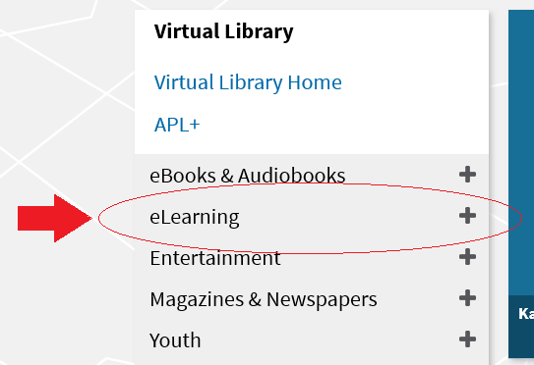
- Click on eLearning on the left side of the screen

- Click on LearningExpress Library (Test Prep)
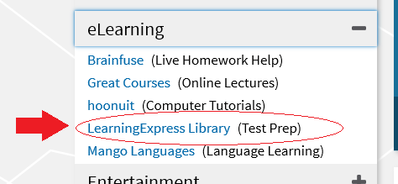

- Click on Access Now
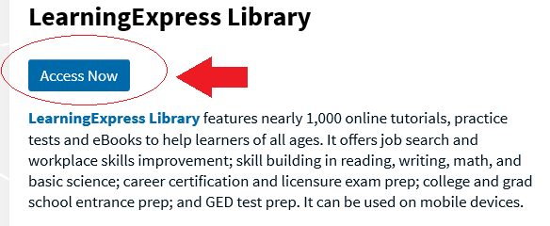

- Sign in using your Library Card number and pin/password.
Need to reset your pin/password? Call Customer Service at 512-974-7475!

- Take your pick of trainings and get started!

