Want to learn a language or need language help?

- Go to: http://library.austintexas.gov/

- Click on rectangle that says Virtual Library

- Click on eLearning on the left side of the screen
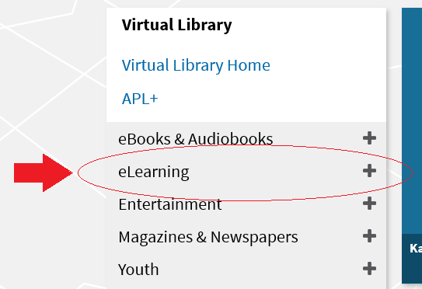

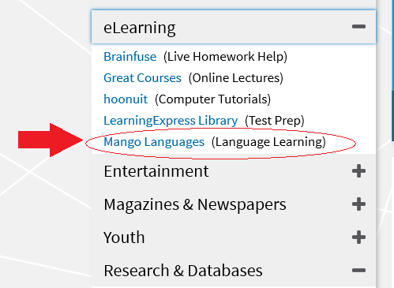
- Click on Mango Languages

- Click Access Now
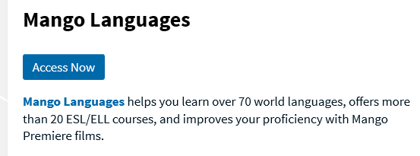
- Sign in using your Library Card number and pin/password.
Need to reset your pin/password? Call Customer Service at 512-974-7475!

- Take your pick of trainings and get started!
  - Create a profile with a username and password
  - Mango keeps track of your process with your account.

- Pick a language and get going!

